***CHANGE THE WAY YOU LEARN ELECTRONICS***

**LAUNCHING SOON...**

**ELECDUINO β version** 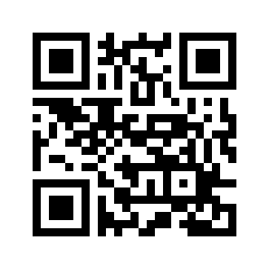

**STAY TUNED..!!**

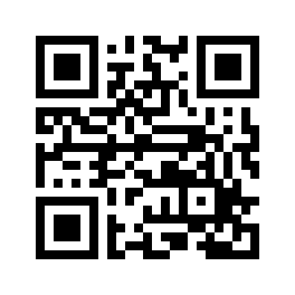

**Provide your Feedback.**

**THANK**

**YOU**

**For your purchase.**

**ELSTP028707**

SAURAV KUMAR (8860394267)

3rd Floor, B5 Tower,  
Magarpatta City, Pune – 411028

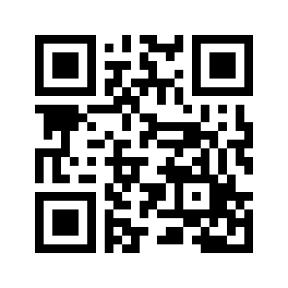

**Visit us for more Products**



**Learn with us**

**We want you to be Contact / Whatsapp Us  
 COMPLETELY SATISFIED 9911806843/8860394267**

 ***(MAKE IT HAPPEN)***